DELETE BUTTON OFF PROGRAM

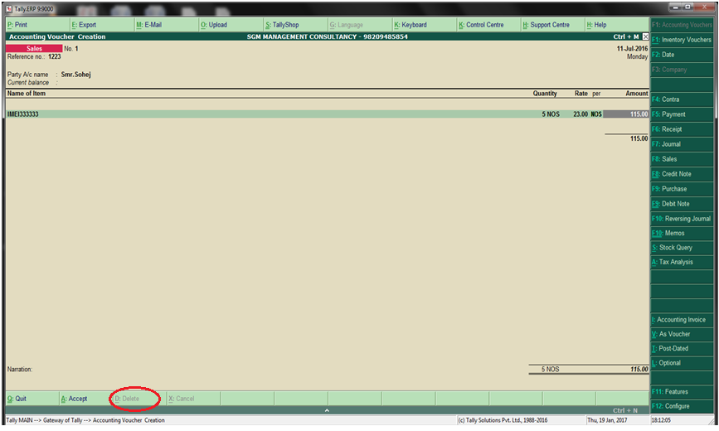
DELETE OFF BUTTON

